DIS-INDO-SUMBAWA-Ancestor Figure

ancestor idol figure from Sumbawa Indonesia. size: 37 cm ; 14.5 inches

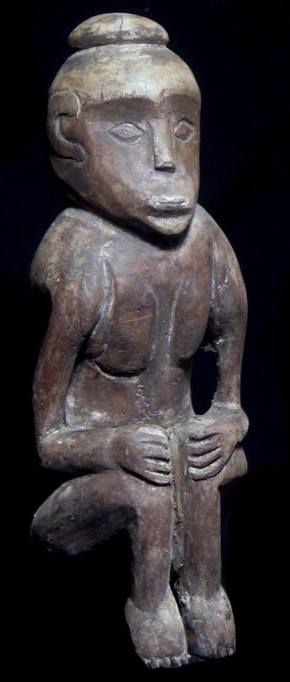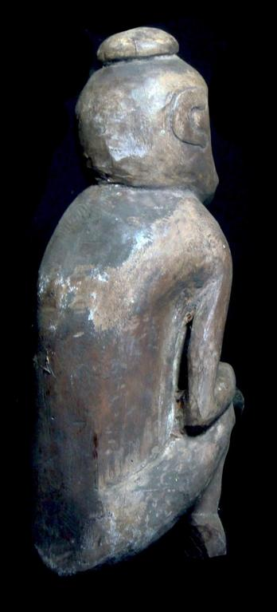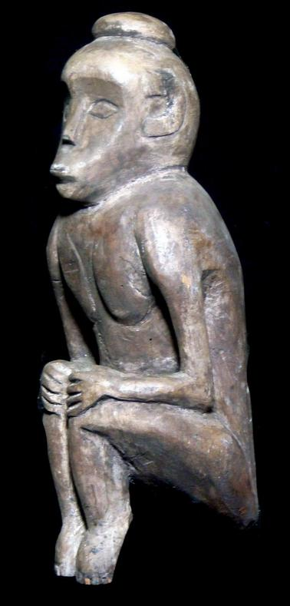

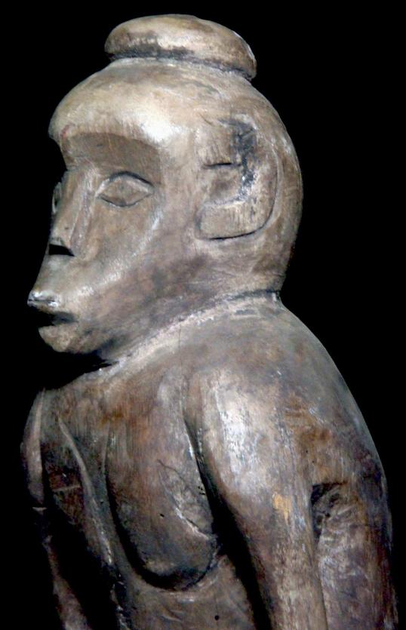

Sold by [new-guinea-art](http://myworld.ebay.com/new-guinea-art) ( [9215](http://feedback.ebay.com/ws/eBayISAPI.dll?ViewFeedback&userid=new-guinea-art) )

### Delivery package 1 of 1

Estimated delivery Thursday, Dec 24, 2015 - Wednesday, Jan 6, 2016

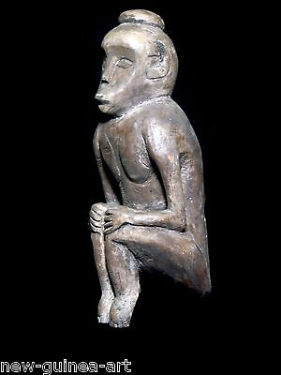

#### [Excellent wooden ancestor idol figure from Sumbawa Indonesia](http://www.ebay.com/itm/141848655149)

|  |  |
| --- | --- |
| Item price | $37.00 |
| Quantity | 1 |
| Item number | 141848655149 |
| Shipping service | Economy Shipping |